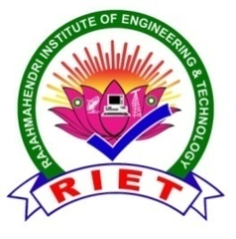 | 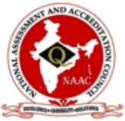  RAJAMAHENDRI  INSTITUTE OF ENGINEERING & TECHNOLOGY  (Approved by AICTE, New Delhi, Affiliated to JNTUK, Kakinada, Accredited BY NAAC)  BHOOPALAPATNAM, RAJAMAHENDRAVARAM, E.G. Dist., AP, 533107.  eMail: office@rietrjy.co.in Website: www.rietrjy.co.in Ph: +91 91212 14413

POLICY DOCUMENT ON FINANCIAL SUPPORT TO TEACHERS

INTRODUCTION:
The institution's policy is to provide financial assistance to teaching staff to conduct research in the college, attend FDPs / research works / conferences/workshops/seminars, symposia / coursera / publication in the nursing field at the state, national & international levels, and to obtain professional membership in the relevant fields. It aims to raise faculty standards by expanding facilities and research skills and by providing a place for them to share their knowledge, experience, and research with the rest of the world.
OBJECTIVE:
- To instill a research tendency in faculty members and to improve their research skills.
- To improve the educational qualifications of teachers.
- To provide a safe environment for teachers to share their knowledge and thoughts.
- To interact with eminent academicians and scientists from research institutions to improve teachers' in-depth knowledge of subjects.
- To make it easier for professors to interact with the rest of the world.
ELIGIBILITY:
- The institute's regular teaching faculty will be eligible for financial aid. Financial assistance is given to attend FDPs / research works/seminars/workshops/conferences/courses/symposia in the field of Nursing at the state, national, and international levels.
- Teaching staff who use the physical facilities/financial aid to complete their Ph.D. program in the time allotted.
- After receiving their doctorate, such faculty must stay at the same university for at least three years.
- Financial assistance is given for research projects and publications published in repetitive journals like SCOPUS/Web of Science/SCI-indexed journals.

PROCEDURE OF APPLICATION AND APPROVAL:
- Teachers are deputed for seminars, workshops or conferences by the department/ committee. The Head of the Department/ Committee Convenor makes an application to the Principal about the teacher participation, their registration fees and any allowances, if applicable. After the approval of the Principal, the funds are released for the same by the Accounts section.
- In case, when the fee is paid by the teacher, the amount is reimbursed after following proper application and approval procedure.
- The deputee teacher needs to submit the relevant receipts and a copy of the attendance certificate to the Accounts section for their record.
- In case of financial appreciation for research paper publication and Ph.D. award, the Convenor of Research & Publication Cell makes a recommendation about the same to the Principal at the end of every academic year. The copy of research papers published by the teachers and the degree certificate of Ph.D. award is maintained by the Cell for their record and reference. After the approval of the Principal, the approved application is forwarded to Accounts section for the release of funds.
- The teachers may be interested to become members of professional bodies. The College sanctions the membership fees upon the application of the concerned teacher for the same. The receipts and records are maintained by the Accounts section.
- There are teachers who may be interested in enrolling for any course to enhance their professional skills. The College sanctions the course fee to the teachers. The receiptsand records for the same are maintained by the Accounts section.

PRINCIPAL SECRETARY

